Practical 14

Part A
1) | Assemble and test: build a tiny layered app (a model, a service using an ArrayList, and a menu main), then write two or three JUnit @Test methods checking that adding increases the count and an invalid action throws — practice before testing MiniBank.
 | Item.java
Code | public record Item(String name) {}
 | ItemService.java
Code | import java.util.ArrayList; public class ItemService {  private ArrayList<Item> items = new ArrayList<>(); public void add(String name) {  if (name == null || name.isBlank()) { throw new IllegalArgumentException("Name required"); } items.add(new Item(name));  }  public int count() { return items.size(); }  public ArrayList<Item> all() { return new ArrayList<>(items); }  }
 | ItemApp.java
Code | import java.util.Scanner; public class ItemApp {  public static void main(String[] args) { ItemService service = new ItemService(); Scanner sc = new Scanner(System.in); while (true) {  System.out.println("1. Add\n2. List\n3. Exit"); String choice = sc.nextLine();  if (choice.equals("3")) { break; } try {  if (choice.equals("1")) {  System.out.print("Name: "); service.add(sc.nextLine());  } else if (choice.equals("2")) { System.out.println(service.all()); } else { System.out.println("Invalid choice"); }  } catch (IllegalArgumentException e) { System.out.println(e.getMessage()); }  }  }  }
 | ItemServiceTest.java
Code | import org.junit.jupiter.api.Test;  import static org.junit.jupiter.api.Assertions.*; public class ItemServiceTest {  @Test void addIncreasesCount() { ItemService service = new ItemService();  service.add("Book"); assertEquals(1,service.count());  }  @Test void blankNameThrows() {  assertThrows(IllegalArgumentException.class, () -> new ItemService().add(" "));  }  @Test void listContainsAddedItem() {  ItemService service = new ItemService(); service.add("Pen"); assertEquals("Pen",service.all().get(0).name());  }  }
Place JUnit Platform Console Standalone 1.10.2 in lib/junit.jar. javac -d out Item.java ItemService.java ItemApp.java
javac -cp "out;lib/junit.jar" -d out ItemServiceTest.java

 | java -jar lib/junit.jar execute --class-path out --scan-class-path On Linux/macOS replace the classpath semicolon with a colon.
Output | 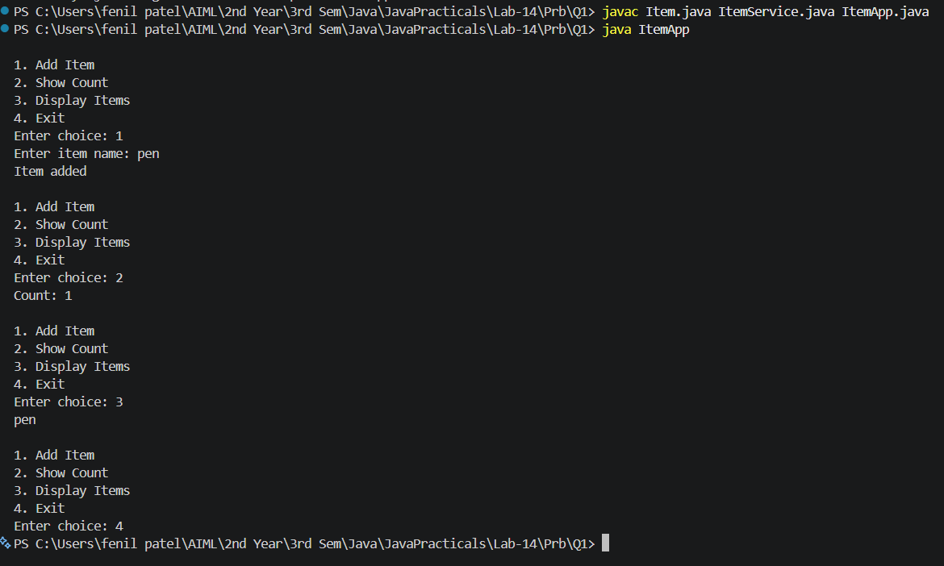

2) | (For Advanced Learners – home) Organise that app into packages, build a runnable JAR, and add a test that saves and reloads its data unchanged.
 | model/Item.java
Code | package model;  import java.io.Serializable;  public record Item(String name) implements Serializable {}
 | service/ItemService.java
Code | package service; import model.Item; import java.io.*; import java.nio.file.*;  import java.util.ArrayList; public class ItemService {  private ArrayList<Item> items = new ArrayList<>(); public void add(String name) {  if (name == null || name.isBlank()) { throw new IllegalArgumentException("Name required"); } items.add(new Item(name));  }  public void save(Path file) throws IOException {  try (ObjectOutputStream out = new ObjectOutputStream(Files.newOutputStream(file))) { out.writeObject(items);  }  }  @SuppressWarnings("unchecked")  public void load(Path file) throws IOException, ClassNotFoundException {  try (ObjectInputStream in = new ObjectInputStream(Files.newInputStream(file))) { items = (ArrayList<Item>) in.readObject();  }  }  public int count() { return items.size(); }  public ArrayList<Item> all() { return new ArrayList<>(items); }  }

 | app/ItemApp.java
Code | package app;  import service.ItemService; import java.util.Scanner; public class ItemApp {  public static void main(String[] args) { ItemService service = new ItemService(); Scanner sc = new Scanner(System.in); while (true) {  System.out.println("1. Add\n2. List\n3. Exit"); String choice = sc.nextLine();  if (choice.equals("3")) { break; } try {  if (choice.equals("1")) {  System.out.print("Name: "); service.add(sc.nextLine());  } else if (choice.equals("2")) { System.out.println(service.all()); } else { System.out.println("Invalid choice"); }  } catch (IllegalArgumentException e) { System.out.println(e.getMessage()); }  }  }  }
 | test/ItemServiceTest.java
Code | package test;  import service.ItemService; import java.nio.file.*;  import org.junit.jupiter.api.Test;  import static org.junit.jupiter.api.Assertions.*; public class ItemServiceTest {  @Test void addIncreasesCount() { ItemService service = new ItemService();  service.add("Book"); assertEquals(1,service.count());  }  @Test void blankNameThrows() {  assertThrows(IllegalArgumentException.class, () -> new ItemService().add(" "));  }  @Test void listContainsAddedItem() {  ItemService service = new ItemService(); service.add("Pen"); assertEquals("Pen",service.all().get(0).name());  }  @Test void saveAndLoad() throws Exception { Path file = Files.createTempFile("items", ".dat"); try {  ItemService first = new ItemService(); first.add("Pen"); first.save(file); ItemService second = new ItemService(); second.load(file); assertEquals(first.all(),second.all());  } finally { Files.deleteIfExists(file); }  }  }
Build from the folder containing model, service, app and test.
javac -d out model/Item.java service/ItemService.java app/ItemApp.java jar --create --file items.jar --main-class app.ItemApp -C out .
java -jar items.jar
javac -cp "out;lib/junit.jar" -d test-out test/ItemServiceTest.java
java -jar lib/junit.jar execute --class-path "out;test-out" --scan-class-path On Linux/macOS use a colon in classpaths.

Output

